BUG report!

Name: ***It couldn`t use iCloud Keychain***

Type: bug

Priority: high

Enviroment: pinterest apk

**Description :  
It couldn’t give a access on my iCloud Keychain when you go to log in field. Can not log in with iCloud Keychain.**

**Steps to reproduce:**

1. **Make internet access**
2. **Open the app store**
3. **In search bar write “pinterest” and download**
4. **Open the “pinterest” apk**
5. **Tap to log in field**
6. **Tap to “Use iCloud Keychain**
7. **It appears error !**
8. **Go to settings**
9. **Open appleID then iCloud**
10. **Find keychain and make sure that is “ON”**
11. **Open again the apk**
12. **Try again to log in with iCloud Keychain**
13. **It appears error again.**

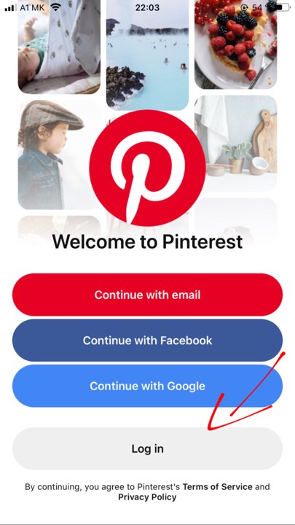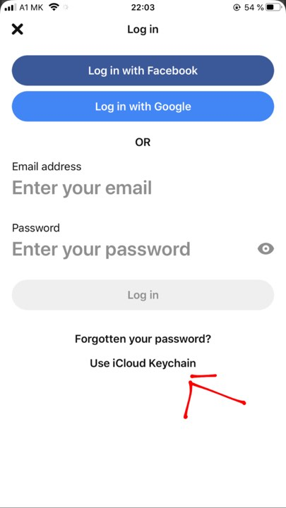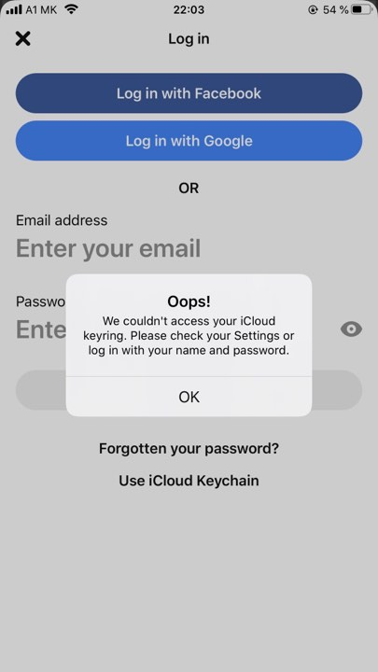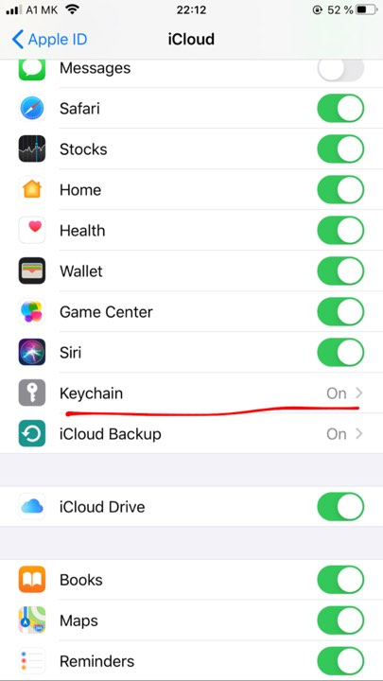

Expected results: When your keychain is “on” you should be log in with your iCloud Keychain account .

Report: This was tested on on Iphone 7plus IOS 13.3 latest version and Iphone 8.